The food camera site

it will contains of four pages (main Page & About us & About the app &contacts )

Common at all pages :   
1-nav bar : contains site logo ( at the left ) & other pages link & android icon direct to download application )

2- footer : contains (All right reserved © to WTX company)

……………………

Home page : contains two sections the

The first one : contains two mobile phones opened the screen shot of registration (after & before )

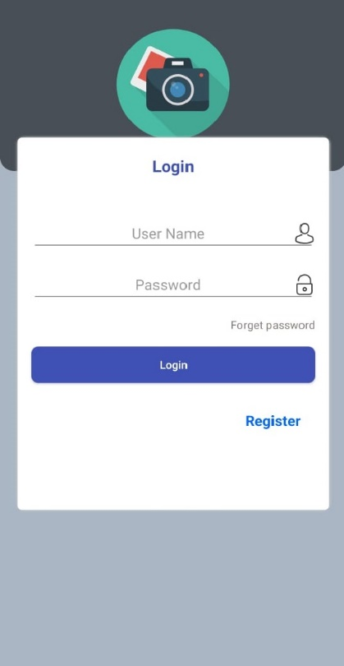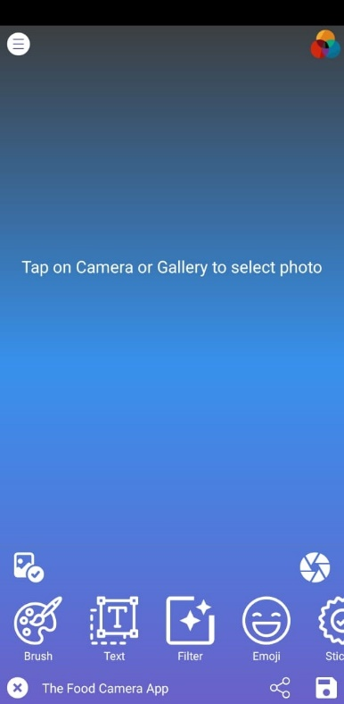

Ang between these two phones (Food Camera is a new specialist camera app that offers a vast array of features )

The second one : contains all screen shot ( attached ) of the application

The second page : contains all data (attached ) about WTX hub company

…. WTX Hub is based in Manchester in the United Kingdom and develops and operates food and beverage focused apps for smartphones in conjunction with developing WTX Hub's own software eco-system for the food & beverage sector.

Since launching this year WTX Hub has developed and expanded WTX Hub's software and technological eco-system predominantly aimed at the food and beverage sector. This includes WTX Hub's own social media platform, WTX Hub Zone, the business to business trading platform, WTX Hub Product Trading Exchange and WTX Hub's own dedicated blockchain backed provenance technology to track and verifying the provenance of all food and beverage goods throughout the retail and supply chain.

As WTX Hub further develop and launch software products for the eco-system, WTX Hub intend to become the leading technology based eco-system for the food and beverage sector in Europe and North America.

For more information about WTX Hub, please visit http://wtxhub.com.

Press Contact:

Media Relations

WTX Hub

The Third page : contains all data (attached ) about Food camera app

…..

Food filters make culinary photos more enticing.

With a selection of over 20 filters optimized for food and drink photography, users can take exactly the type of food and drink photos they want.

Brush gives license to users to create their own art and creative drawings that are integrated with the original image.

Users can add own text message to original image.

There are hundreds of different emojis and stickers that fit all tastes and occasions from business dinners to friend's nights out.

The user can manually make the image brighter or darker, change the focus, and numerous other alterations to their taste when taking pictures.

Sharing through a variety of services.

Processed photos can be shared not only through WTX Hub but also on social networks such as Facebook, Twitter, and Instagram.

App Overview

App name: Food Camera

Supported devices: Android

Cost: Free to download, In-app purchases apply

Developer and operator: WTX Hub

Copyright: © WTX Hub

The forth page : Contains all contacts of WTX company ( attached )

….. For more information about WTX Hub, please visit http://wtxhub.com.

Press Contact:

Media Relations

WTX Hub

contact@wtxhub.com

SOURCE: WTX Hub

Created by : Eng / Mohamed Ahmed